Programming Languages Homework 3

Questions

1. C++ supports encapsulation by letting users create their own types aka Classes
2. Function overriding is the main problem with multiple inheritance aka when a function inherits the same named method from two different parent classes. C++ uses virtual functions to solve this problem.
3. A friend function is defined outside of its classes scope but has the right to access all members of the class.
4. Because some tools such as cin are used so commonly its easier to use a namespace instead of writing std::cin every time.
5. Parameters are passed in as arguments when a function is called.
6. Because you can write code in c++ without creating a class. The main function isn’t even a member of an object.

Screen Shots



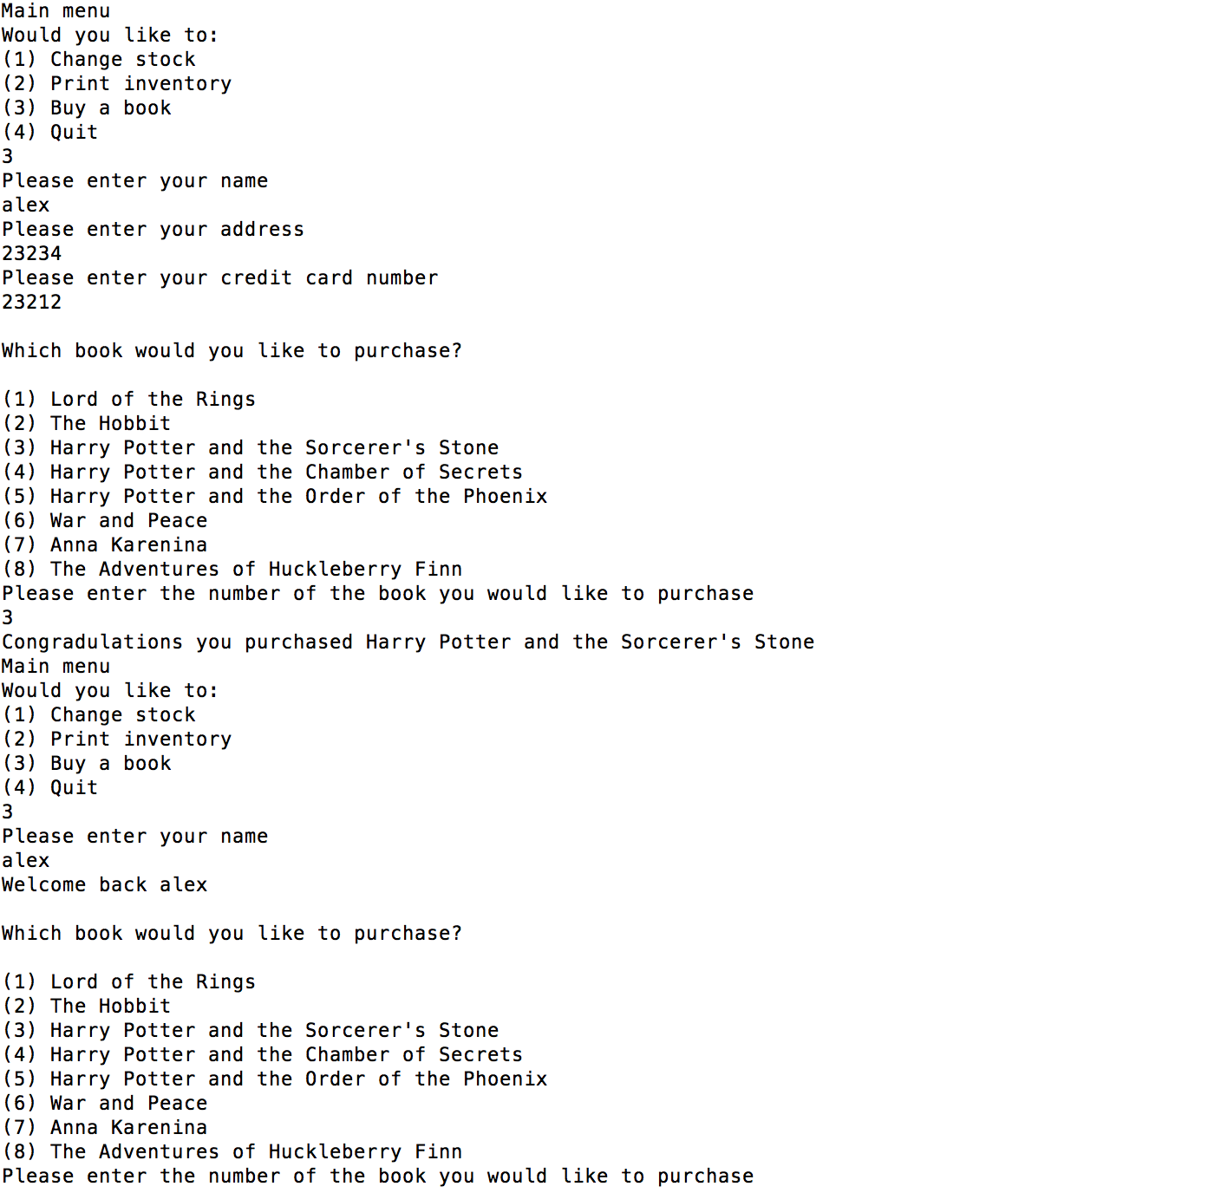

I had to run valgrind on a friends computer because mine would not install

